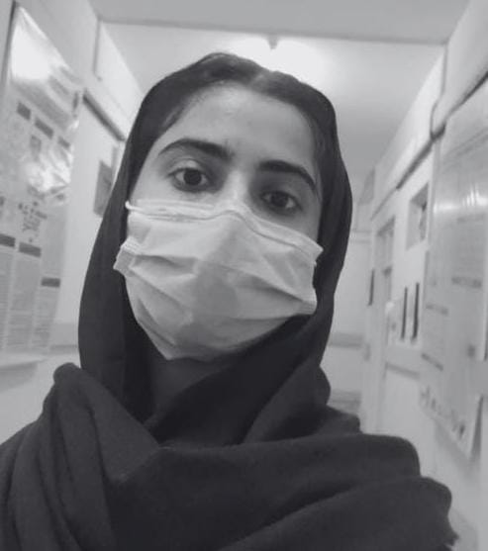

**Abiha Munawar**   
Lahore , Pakistan  
03214543810  
abiha.munawar12@gmail.com  
[linkedin.com/in/abiha-munawar-40717b30b](https://www.linkedin.com/in/abiha-munawar-40717b30b)

**Objective**

Motivated and dedicated Software Engineering student at Lahore College for Women University (LCWU) with hands-on experience in web development.

Currently enhancing my skills through an internship at Webdev Masters collaboration with ECC international

Active participation in the ACM UET Fellowship. Seeking opportunities to apply my knowledge and grow in a dynamic environment.

**Education**

**Bachelor of Science in Software Engineering**  
*Lahore College for Women University (LCWU)*

* *Expected Graduation: 2027*
* Completed 2nd semester

**FSC Pre Medical**

Punjab Group of Colleges

* 2021-2022
* A+ (1030)

**Matriculation**

Sabzazar High School Lahore

* 2019-2021
* A+(1035)

**Experience**

**Front-End Intern**  
*Webdev Masters*

* *8,July 2024- 2 ,Sep,2024*
* Collaborated on various web development projects, focusing on responsive design and user experience.
* Developed and maintained web pages using HTML, CSS, and JavaScript.
* Currently exploring React to build dynamic user interfaces.

**Fellowship**

**ACM UET Fellowship**

* *July,2024 - August,2024*
* Participated in workshops and mentoring sessions to enhance technical skills and industry knowledge.
* Worked on projects and tasks under the guidance of experienced professionals.

**Skills**

* **Languages & Technologies:** HTML, CSS, JavaScript, React
* **Tools:** Git, Visual Studio Code, Chrome Developer Tools
* **Soft Skills:** Problem-solving, Teamwork, Time Management

**Projects**

**Profile Page Design**

* Created a personal profile page using HTML and CSS, focusing on clean design and responsive layout.

**Landing Page for Coffee Shop**

* Designed and developed a landing page for a coffee shop, integrating text and images with a focus on aesthetics and usability.

**Recipes Website**

**Quizzes and Tasks at my Internship**

Top of Form

Bottom of Form